
CiTIZENS WITH DISABilITIES DAYAT FRONTiER DAYS
FRIDAY, JULY 3rd
Recreation Park
500 E. Miner Street in Arlington Heights

Citizens with Disabilities Day celebrates individuals
with disabilities and their families.
9:30 - 11:00am Check-in at Hickory Street Entrance
10:00 - 11:15am Rides
11:30am - 2:00pm Luncheon and Entertainment
For more details and to register for the event visit: https://www.frontierdays.org/citizens/

Hosted by Frontier Days

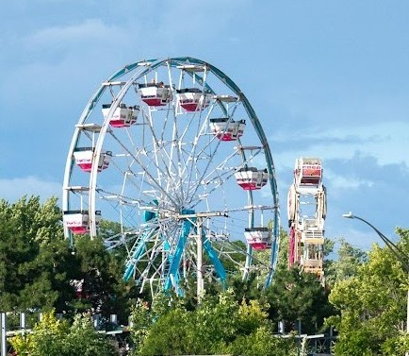
Sponsored by:

North American Midway
Jewel Osco
4Sure Entertainment
VAH Commission for Citizens with Disabilities
ATA Group Ltd.

